Admin Panel Screenshot 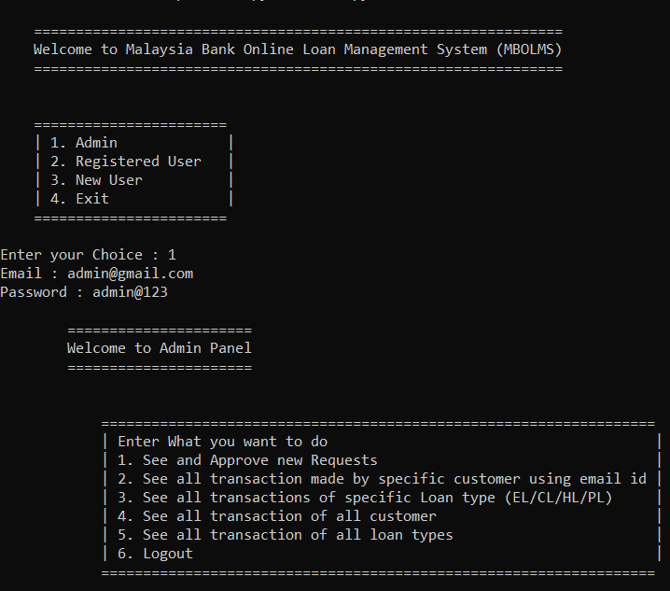Screenshot of see and approve requests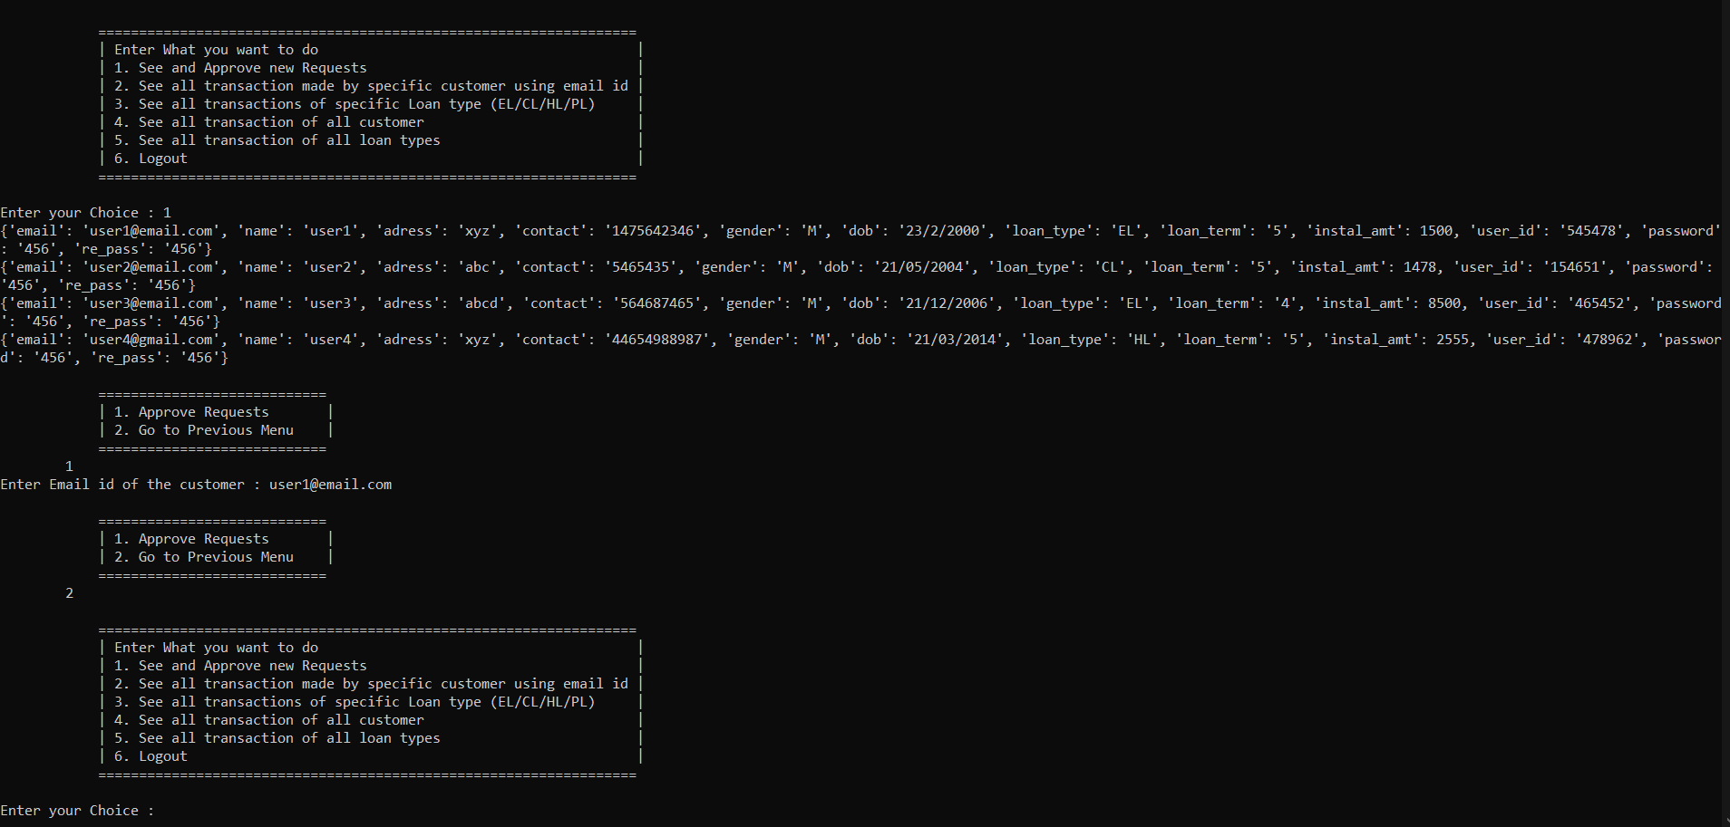

Screenshot of Loan and Customer specific transaction history

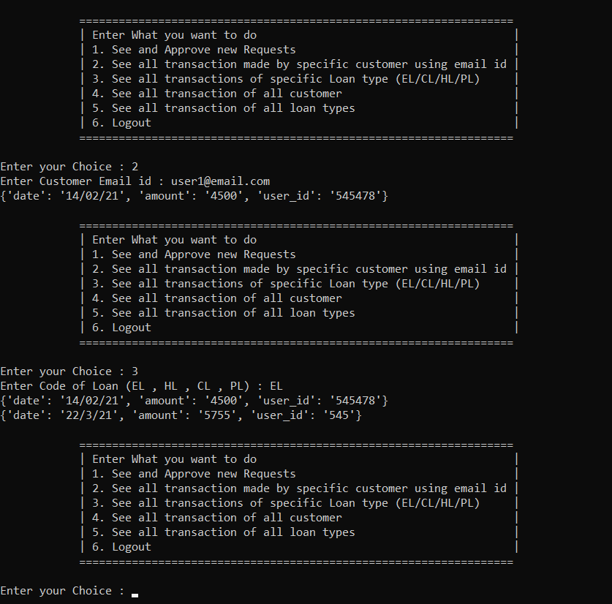

Screenshot of transaction all customer and loan types

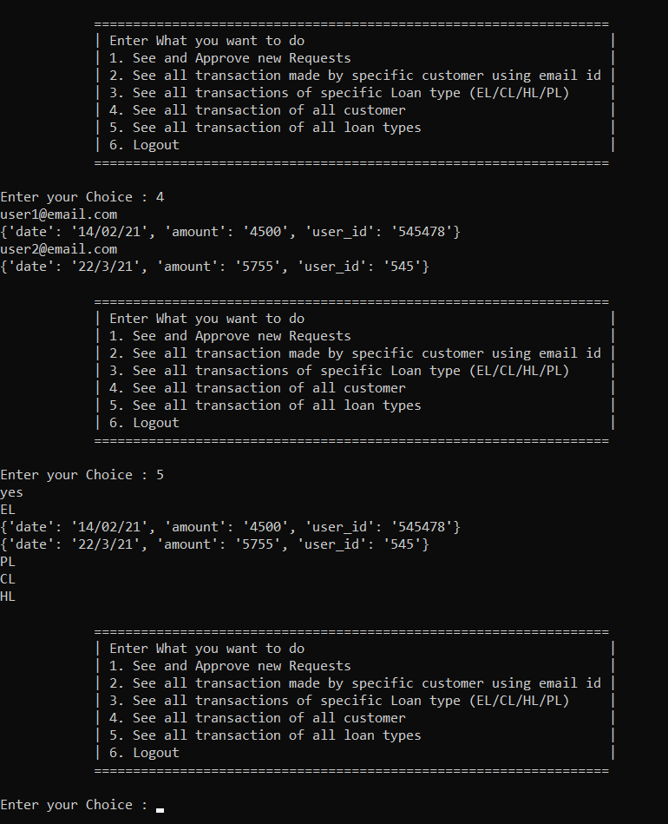

Screenshot of Login into user panel , see loan details, see own transaction

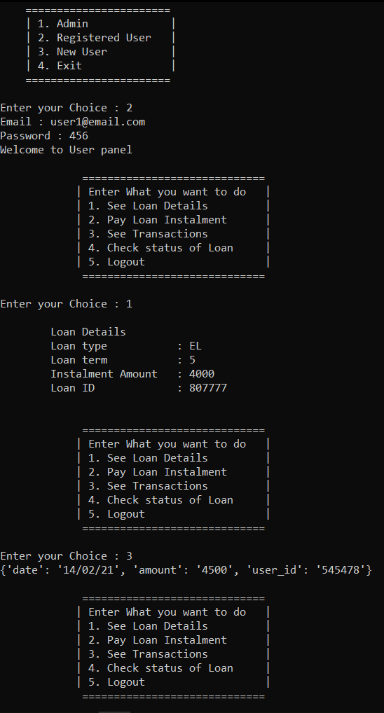

Screenshot of Pay loan Instalment and See Transaction

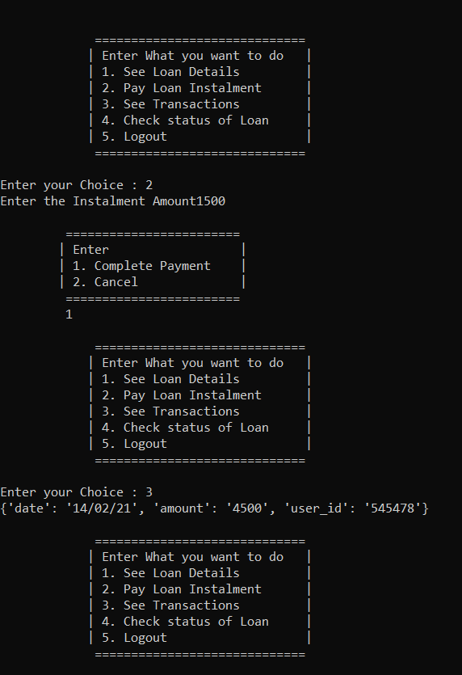

New User Panel and check loan details

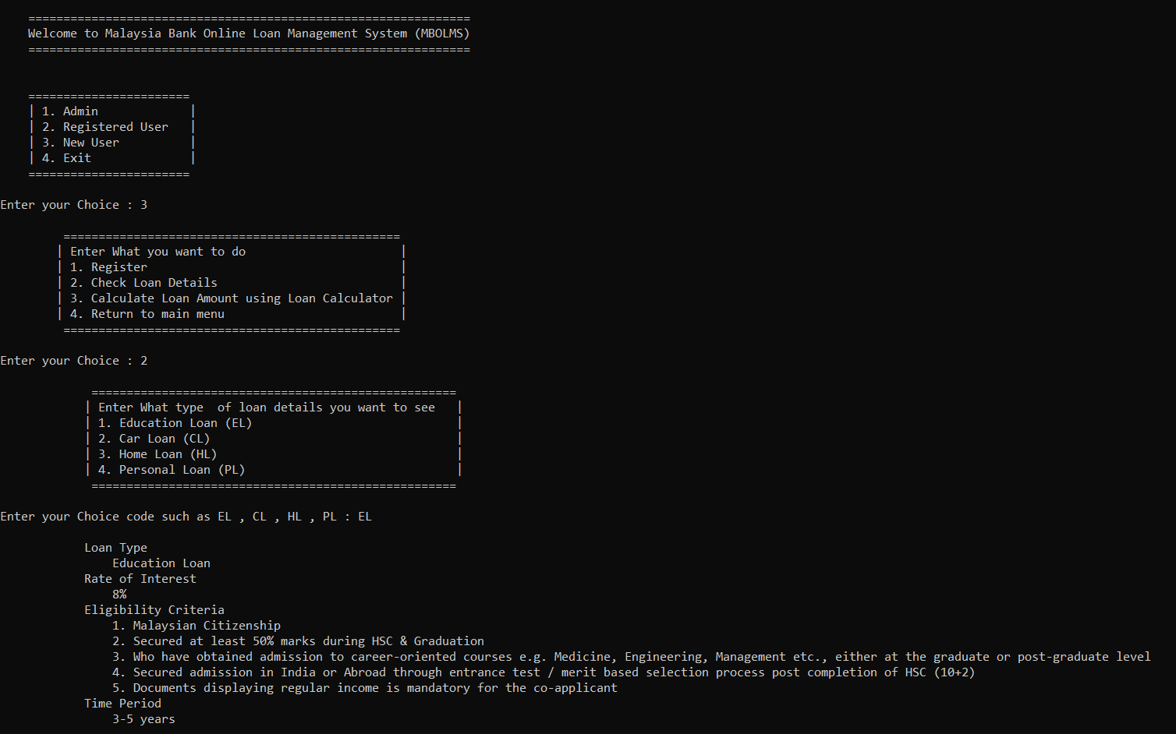

Loan Calculator

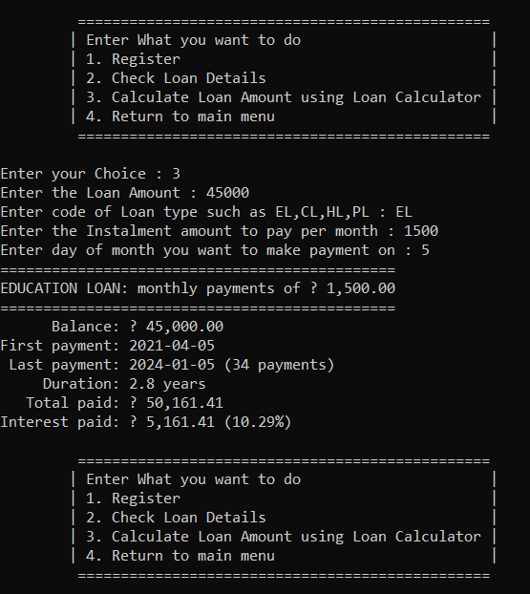

Screenshot of Registration of new user

